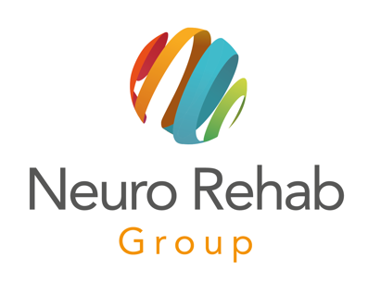

Ian Connell
Curriculum Vitae

Ian qualified as an Occupational Therapist in 1995 with a BSC (Hons) from Derby University. Since then he has worked across a wide range of clinical areas, building and developing his clinical skills and knowledge.

He has worked mainly with adults age 16 and above, with experience in mental health, older persons care, orthopaedics, neurological rehabilitation, vocational rehabilitation, rheumatology, hands, and pain management. He has applied his skills within inpatient, outpatient and community settings.

Brain injury rehabilitation has always been his passion and even during a 5-year period when he held a management role, he continued to provide hands on support to a neurorehabilitation service.

Ian joined the Neuro Rehab Group in early 2018 and during this time he has supported clients with acquired brain injuries and other conditions to achieve the goals that are meaningful to them. He has also provided work place assessments to businesses and worked closely with charities as part of this role.

He also works as a Locum Occupational Therapist, supporting the development of a therapy access and intervention service, providing assessment and treatment to clients in need of urgent care and reablement.

Ian is passionate and professional with a good sense of humour; he believes in enabling people to improve their quality of life, embracing the challenges and obstacles to support individuals to achieve their goals.

Ian is based in Wolverhampton and provides occupational therapy support to adults with brain injury around the North West and West Midlands.

